Junior Infants 2016/17

Parent Information Booklet

WELCOME

Dear Parents,

Welcome to a new and exciting stage in your child’s life. This is the beginning of a journey that will last 14 years and help shape your child’s future.
During this year your child will make new friends, enjoy new experiences and learn new skills. Parents and teachers will work together to ensure that at the end of this school year your child will have a positive attitude towards education, based on social and academic confidence.

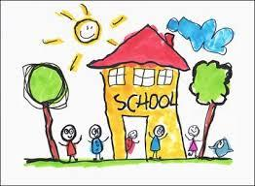

Today you are creating a memory, make sure it is a happy one!

Please be positive with your child in preparing him/her for school and explain what will happen regarding teacher, other
children, breaks, sitting down and tidy-up time.
You may enter the school at the Infant Door. This is where your child will line up every day.
On arrival it is very helpful if you can show your child where to hang his/her coat. After meeting the teacher, the other children and finding your child’s place, please leave promptly because your child will pick up on your anxiety.
Most children, even if initially upset, soon become distracted by their surroundings and settle down. Although it is very difficult to leave a child that is upset the teacher will ensure that they are settled and happy as quickly as possible. Other children that were fine can become upset as their parent didn’t stay.
Camcorders or cameras are not allowed on school grounds. If you wish to photograph your child please do so outside of school. (This is in line with best practices in child protection, Children First,2011)
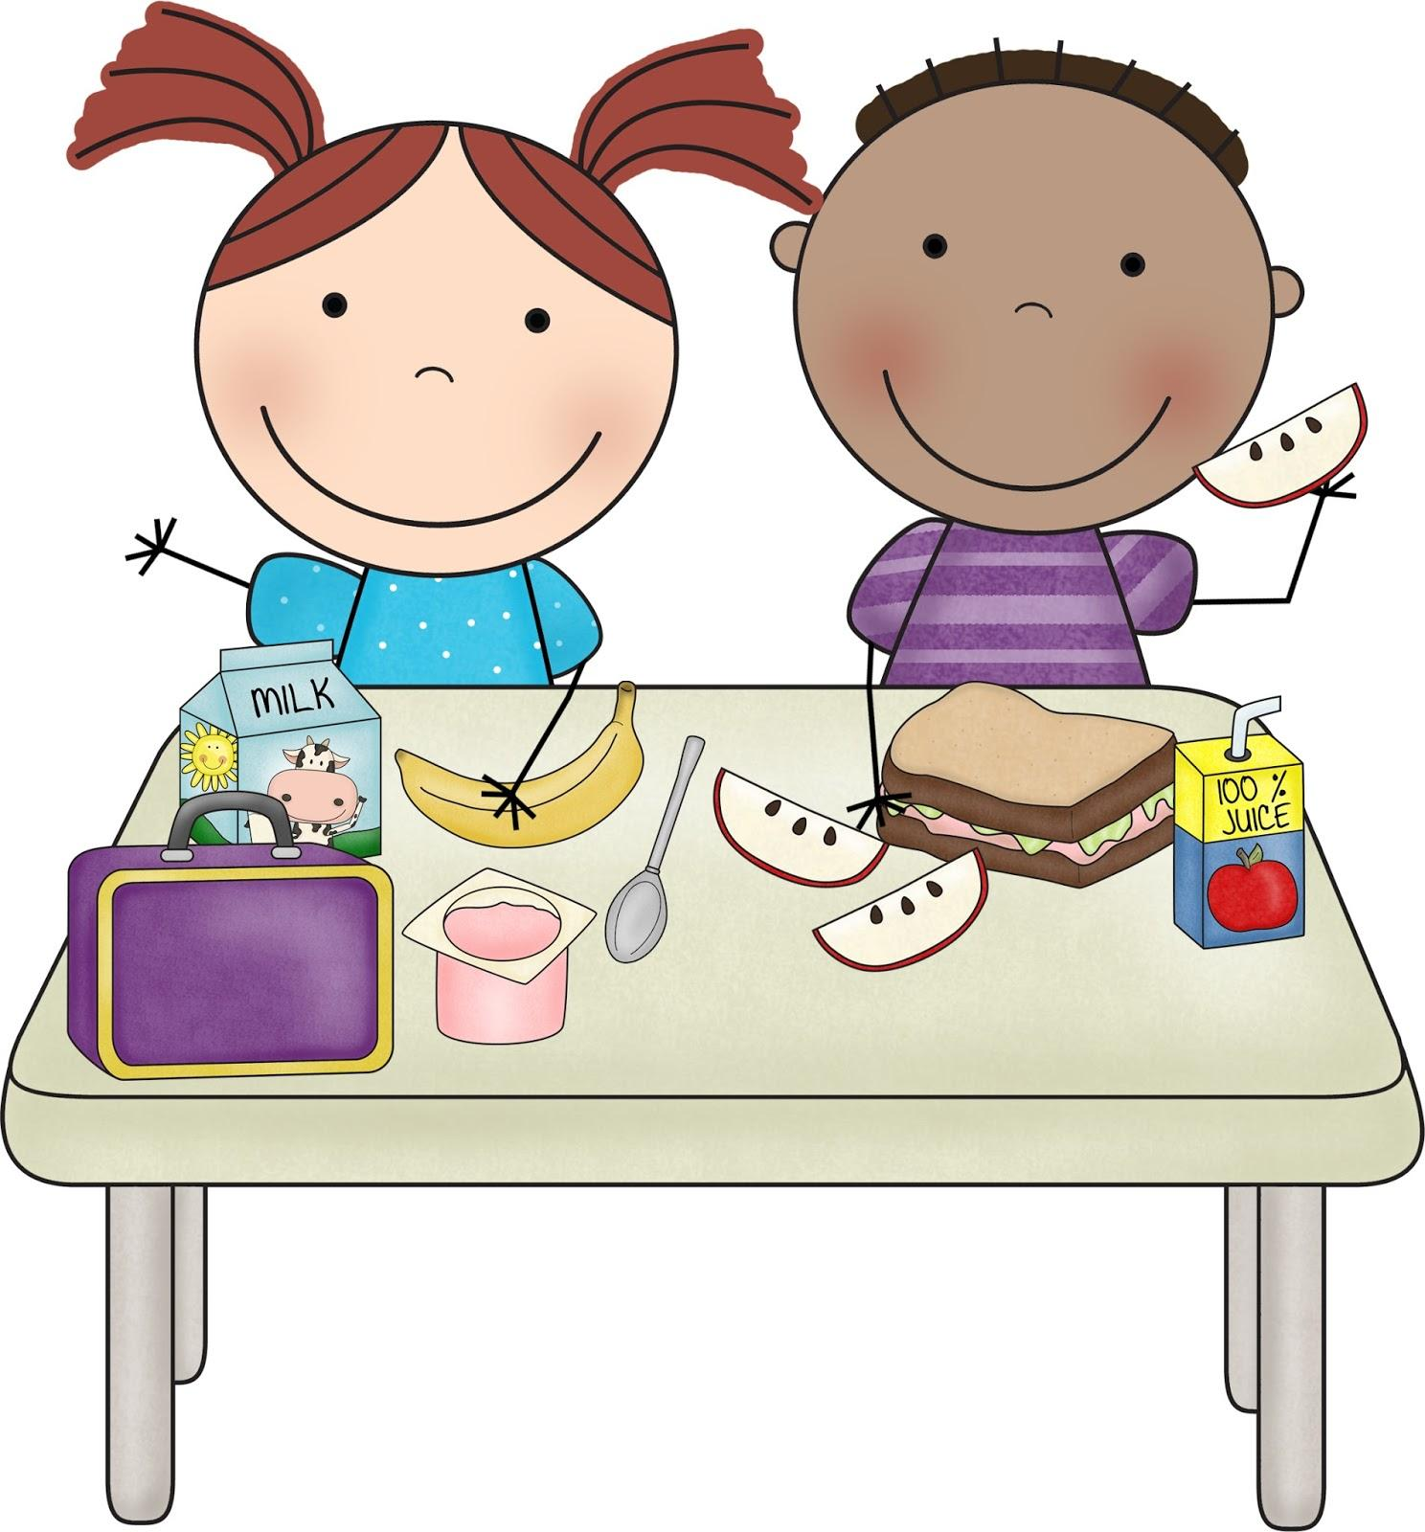
Breaks

All classes have two breaks. The first break is from 10.50-11.00 and the second from 12.30-1.00.Your child will be given adequate time to eat a small lunch.
Lunch

As we have a healthy lunch policy in our school, bars, biscuits, cakes, crisps, popcorn etc. are not allowed except on Friday when only one treat is allowed. Crisps, peanuts and chewing gum are not allowed in school at any time. Make sure that your child can manage their lunch. Can they open and close their lunch box and drink? Pre-peel oranges etc. so they can independently eat their lunch.
Please provide your child with a refillable water bottle as they will be allowed access to this throughout the day.

As there is a pupil in our school with a severe nut allergy; no nuts, food containing nuts or nut products (e.g. Nutella) are allowed on the school premises.

Home-School Communication

Most communication from school to home will happen by e-mail or by text. Please check both regularly. If there is any change to your e-mail address and/or phone number inform the school immediately and we will update our database. You may also email the teacher of any issues that arise, however we would request that a meeting should be arranged for any concerns/sensitive information.
At times there may be forms or written notes that your child will need to bring home. These will be kept in the homework folder. They may be retuned in the same way.

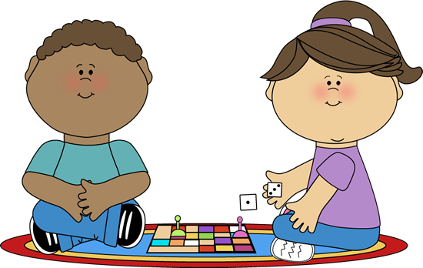
Toys
Children should not bring toys into school. We do not encourage this practice because of breakages, competition and peer pressure. There will be opportunities for “Show and Tell” during the year but you will be told of these in advance.

Absences
For all absences, a note detailing the exact reason for your child’s absence must be given to the school on your child’s return to school. A phone call will not suffice. Under the terms of the Education Welfare Act, 2008, all absences must be recorded. If a child is absent for 20 days or more a report must be sent to Túsla.
The school strongly discourages parents from withdrawing children for family holidays during the academic year.

Roll call is taken each day at 9.10am and all children arriving after this time will be marked as late.

Hometime
Junior Infant’s day finishes at 1.30pm. Please come promptly as your child may fret if you are not on time. The children will be dismissed from the main door to a waiting adult. They are not allowed out until the teacher sees this adult.

If for any reason collection arrangements are being changed, please inform the teacher in advance. It will not suffice for the child to inform the teacher verbally. If you find that for reasons beyond your control you will not be able to collect your child on time, please ring the school secretary who will then relay your message to the teacher.
The school day begins at 8.50 am. Children are not permitted to be on school grounds prior to this time. Parking outside the school for an extended period of time is discouraged as spaces are limited. Please respect the yellow boxes and do not park in them. They are there to ensure the safety of ALL our children.

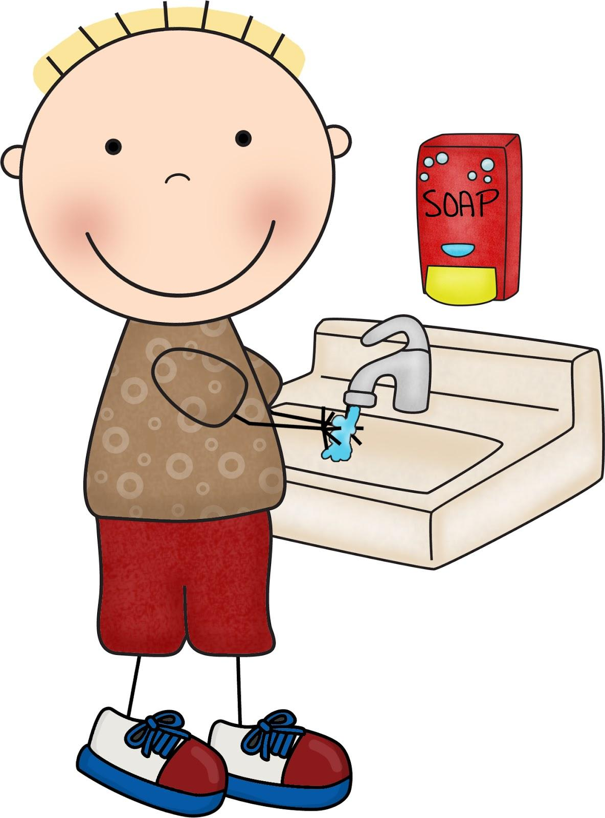
Health and Safety

As part of our school health programme, we encourage regular washing of hands, particularly around eating time and after toilet use. We are not however always able to oversee this so please remind your child of the importance of personal care and practice with them at home. Unfortunately, germs and viruses spread very quickly in a classroom environment, so it is vital that the children are encouraged to use a tissue when they have a runny nose and to cover their mouth when coughing. If your child develops any contagious illness such as chickenpox, please keep him/her away from school until the period of contagion is over and inform the teacher immediately. We recommend that you check your child’s hair regularly for head lice, If necessary treat immediately and inform the school so that notification of possible risk may be sent out to other parents. All information regarding your child’s health is treated in the strictest of confidence.
School Uniform
The uniform consists of a grey pinafore, skirt or trousers, grey shirt and socks, navy tie, navy jumper or cardigan.
Please note that girls may wear school trousers. The uniform can be purchased at chain stores.Please purchase black school shoes to wear with the school uniform.
We have a personalised school tracksuit which is
available from Mc Carthy’s Sportsworld, Glanmire.
When purchasing a school bag please buy one large enough to hold A4 size books and folders. Wheelie bags are not allowed as they topple easily causing the long handles to fall out. For this reason, they can be very dangerous in a classroom.
Please purchase a lunchbox that fits easily into your child’s bag. Large “suitcase” types are not suitable.

Please label all clothing and belongings even footwear as often a few children have the same shoes. It is impossible to keep track of items of clothing unless they are clearly labelled. The
school will not be responsible for lost items which were not clearly labelled.
P.E.

All children are required to have the school tracksuit which is worn for P.E.(twice a week) and on other
occasions. Runners are to be worn with the tracksuit. When buying shoes or runners please bear in mind that your child should be able to tie them him or herself. Velcro fasteners will enable him/her to change quickly and independently.
All children are encouraged to actively participate in all P.E. classes. Swimming classes are taken in the last term each year (2nd – 4th class only). The school has been taking part in Sciath na Scol (hurling and football) since 1988 with great success. Each year the children run in the Cork Primary School Sports.
Erin’s Own coaches train the children in hurling and football.
As there is no available indoor space for P.E inclement weather may mean that the lesson is cancelled or held in the classroom. Please be assured that this will be noted and the required amount of P.E will be given over the whole school year.
Homework

The infant class teacher will send an e-mail each Friday outlining the homework to be completed for the following week. You should take the time to complete this homework with your child and sign it when it has been completed, noting for the teacher if your child is experiencing any difficulty.

At the beginning of the new term the Infant Class teacher will organise an information session for parents outlining her expectations for the year. It is important that one parent from each family attends. This is also an opportunity to ask question that are not covered in this booklet or about issues that arise in the first couple of weeks.
Please note due to heath and safety while the teacher is available anytime for meetings it is not appropriate to ask questions/discuss issues as children enter school in the morning.
Parent Teacher meetings are normally held in November.
Writing
The children will be learning to write lower case letters initially so it would be helpful if you could use these when writing with your child. Capital letters should only be used at the beginning of your child’s name, not in the middle!
Pencil-grip and posture are essential to fluency in handwriting so please encourage proper grip and posture at all times. The teacher will discuss these with you at the meeting.
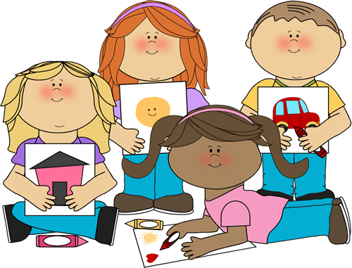
Preparing Your Child for Schoolwork

Good writing is all about muscle and motor control so it will help your child greatly if he/she has lots of practise at colouring, drawing and painting. Practice at manipulating plasticene, construction materials, jigsaws etc. are also vital to your child’s development. Noting visual differences is essential to reading and this skill is practised and encouraged by use of matching games. Reading aloud to your child will cultivate an interest in, and love of reading. Nursery Rhymes teach essential pre reading skills.

Green School

We are an environmentally aware school and have been awarded our third Green Flag. We encourage reducing waste and energy, re-using materials and recycling. In September you will receive a note regarding our Green School practices!
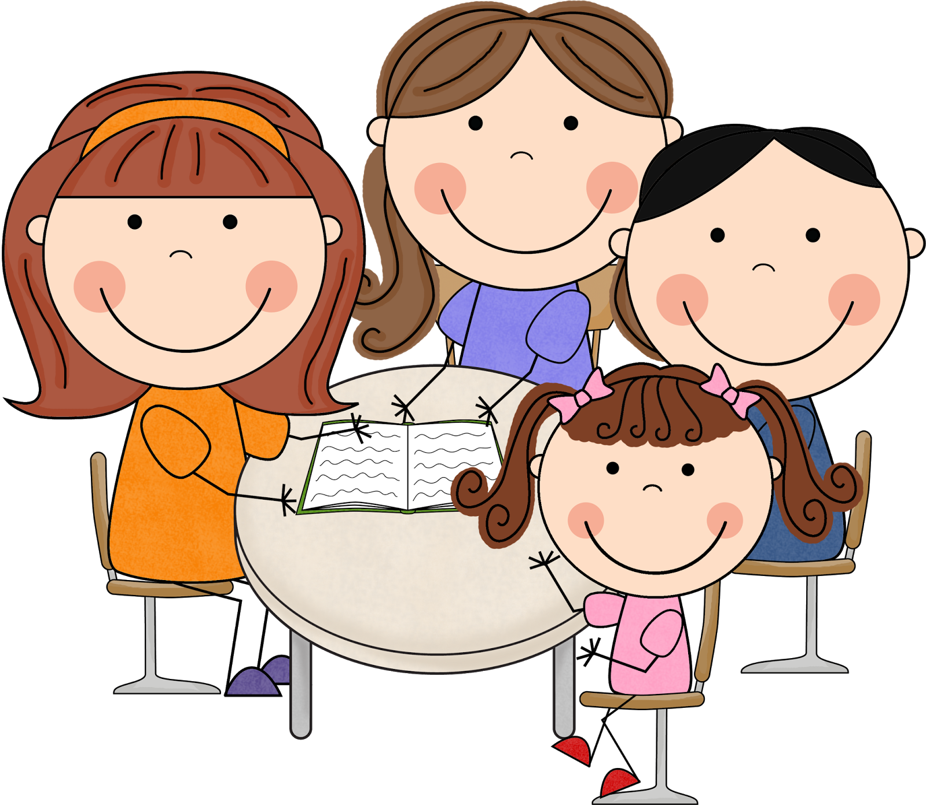
Board of Management

The Board Of Management of Scoil Mhuire asks each family for a voluntary
contribution. For a number of years this was €150 per family per year. Due to the extension of the school the board consulted with parents at a general meeting during the school year 2011/ 2012. As a result the voluntary contribution was increased to €250 per family per year.
This money is used to subsidise the running costs of the school and also is used to subsidise the cost of activities and resources for the children. In addition, a portion will be used to fund the repayment of a loan which was necessary to complete our lovely new extension and corridor.

This contribution is payable in one instalment at the start of the year or on a monthly basis.
If any family is not in a position to pay €250, then a contribution of any amount is gratefully received.
All monies sent to the school should be put in an envelope clearly stating the name of your child, amount enclosed and the purpose of the remittance. A receipt will be issued for all monies received.

Items needed on the first day:
- All books clearly labelled.These will be collected and left in school.
- A small lunch/snack.
- Full uniform clearly labelled.
Your child does not need any pencils/crayons/pencil case/copies etc. These will be supplied by the teacher and you will be informed of monies owed!

Please note that Junior Infants will finish at
12 o’clock for the first week and at 1.30pm thereafter

WE’LL SEE YOU IN SEPTEMBER!

